**Hive project -2**

Objective - The assignment is meant for you to apply learnings of the module on Hive on a real-life dataset. One of the major objectives of this assignment is gaining familiarity with how an analysis works in Hive and how you can gain insights from large datasets.

Problem Statement - New York City is a thriving metropolis and just like most other cities of similar size, one of the biggest problems its residents face is parking. The classic combination of a huge number of cars and a cramped geography is the exact recipe that leads to a large number of parking tickets.

In an attempt to scientifically analyse this phenomenon, the NYC Police Department regularly collects data related to parking tickets. This data is made available by NYC Open Data portal. We will try and perform some analysis on this data.

Download Dataset - https://data.cityofnewyork.us/browse?q=parking+tickets

Note: Consider only the year 2017 for analysis and not the Fiscal year.

The analysis can be divided into two parts:

Part-I: Examine the data

1.) Find the total number of tickets for the year.

2.) Find out how many unique states the cars which got parking tickets came from.

3.) Some parking tickets don’t have addresses on them, which is cause for concern. Find out how many such tickets there are(i.e. tickets where either "Street Code 1" or "Street Code 2" or "Street Code 3" is empty )

Part-II: Aggregation tasks

1.) How often does each violation code occur? (frequency of violation codes - find the top 5)

2.) How often does each vehicle body type get a parking ticket? How about the vehicle make? (find the top 5 for both)

3.) A precinct is a police station that has a certain zone of the city under its command. Find the (5 highest) frequencies of:

a.) Violating Precincts (this is the precinct of the zone where the violation occurred)

b.) Issuer Precincts (this is the precinct that issued the ticket)

4.) Find the violation code frequency across 3 precincts which have issued the most number of tickets - do these precinct zones have an exceptionally high frequency of certain violation codes?

5.) Find out the properties of parking violations across different times of the day: The Violation Time field is specified in a strange format. Find a way to make this into a time attribute that you can use to divide into groups.

6.) Divide 24 hours into 6 equal discrete bins of time. The intervals you choose are at your discretion. For each of these groups, find the 3 most commonly occurring violations

7.) Now, try another direction. For the 3 most commonly occurring violation codes, find the most common times of day (in terms of the bins from the previous part)

8.) Let’s try and find some seasonality in this data

a.) First, divide the year into some number of seasons, and find frequencies of tickets for each season. (Hint: A quick Google search reveals the following seasons in NYC: Spring(March, April, March); Summer(June, July, August); Fall(September, October, November); Winter(December, January, February))

b.)Then, find the 3 most common violations for each of these seasons.

#creating the table:

create table parking(

Summons_Number string,

Plate_ID string,

Registration_State string,

Plate_Type string,

Issue_Date string,

Violation_Code int,

Vehicle_Body_Type string,

Vehicle_Make string,

Issuing_Agency string,

Street_Code1 string,

Street_Code2 string,

Street_Code3 string,

Vehicle_Expiration_Date string,

Violation_Location int,

Violation_Precinct int,

Issuer_Precinct int,

Issuer_Code int,

Issuer_Command string,

Issuer_Squad string,

Violation_Time string,

Time_First_Observed string,

Violation_County string,

Violation_In_Front_Of_Or_Opposite string,

House_Number string,

Street_Name string,

Intersecting_Street string,

Date_First_Observed string,

Law_Section int,

Sub_Division string,

Violation_Legal_Code string,

Days_Parking_In_Effect string,

From_Hours_In_Effect string,

To_Hours_In_Effect string,

Vehicle_Color string,

`Unregistered_Vehicle?` int,

Vehicle_Year int,

Meter_Number string,

Feet_From_Curb int,

Violation_Post_Code string,

Violation_Description string,

No_Standing_or_Stopping_Violation string,

Hydrant_Violation string,

Double_Parking_Violation string)

row format delimited

fields terminated by ', '

tblproperties(' skip.header.line.count'= ' 1');

load data local inpath 'file:///parking.csv' into table parking;

#creating table with ORC format

create table parking_orc(

Summons_Number string,

Plate_ID string,

Registration_State string,

Plate_Type string,

Issue_Date string,

Violation_Code int,

Vehicle_Body_Type string,

Vehicle_Make string,

Issuing_Agency string,

Street_Code1 string,

Street_Code2 string,

Street_Code3 string,

Vehicle_Expiration_Date string,

Violation_Location int,

Violation_Precinct int,

Issuer_Precinct int,

Issuer_Code int,

Issuer_Command string,

Issuer_Squad string,

Violation_Time string,

Time_First_Observed string,

Violation_County string,

Violation_In_Front_Of_Or_Opposite string,

House_Number string,

Street_Name string,

Intersecting_Street string,

Date_First_Observed string,

Law_Section int,

Sub_Division string,

Violation_Legal_Code string,

Days_Parking_In_Effect string,

From_Hours_In_Effect string,

To_Hours_In_Effect string,

Vehicle_Color string,

`Unregistered_Vehicle?` int,

Vehicle_Year int,

Meter_Number string,

Feet_From_Curb int,

Violation_Post_Code string,

Violation_Description string,

No_Standing_or_Stopping_Violation string,

Hydrant_Violation string,

Double_Parking_Violation string)

Stored as ORC;

#inserting data to ORC table only 2017 year data

insert overwrite table parking_orc select * from parking where year(to_date(from_unixtime(unix_timestamp(issue_Date,'MM/dd/yyy')))) = '2017' ;

#enabling vectorization

set hive.vectorized.execution.enabled = true;

#**Vectorized query execution** streamlines operations by processing a block of 1024 rows at a time. Simple operations like arithmetic and comparisons are done by quickly iterating through the vectors in a tight loop, with no or very few function calls or conditional branches inside the loop.

**Note:**To use vectorized query execution, you must store your data in ORC format.

Part-I: Examine the data

1. **Find the total number of tickets for the year.**

show tblproperties parking_orc;

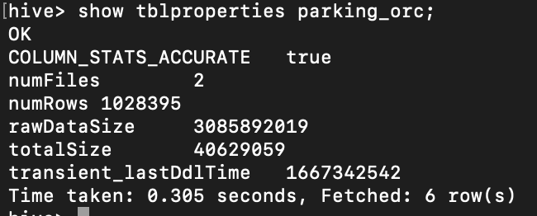

#no duplicates are in ticket numbers (i.e., select (*),count(distinct(Summons_Number)) from parking_orc)

**2.) Find out how many unique states the cars which got parking tickets came from.**

select Registration_State, count(*) as frequency from parking_orc group by registration_state distribute by frequency sort by registration_state desc;

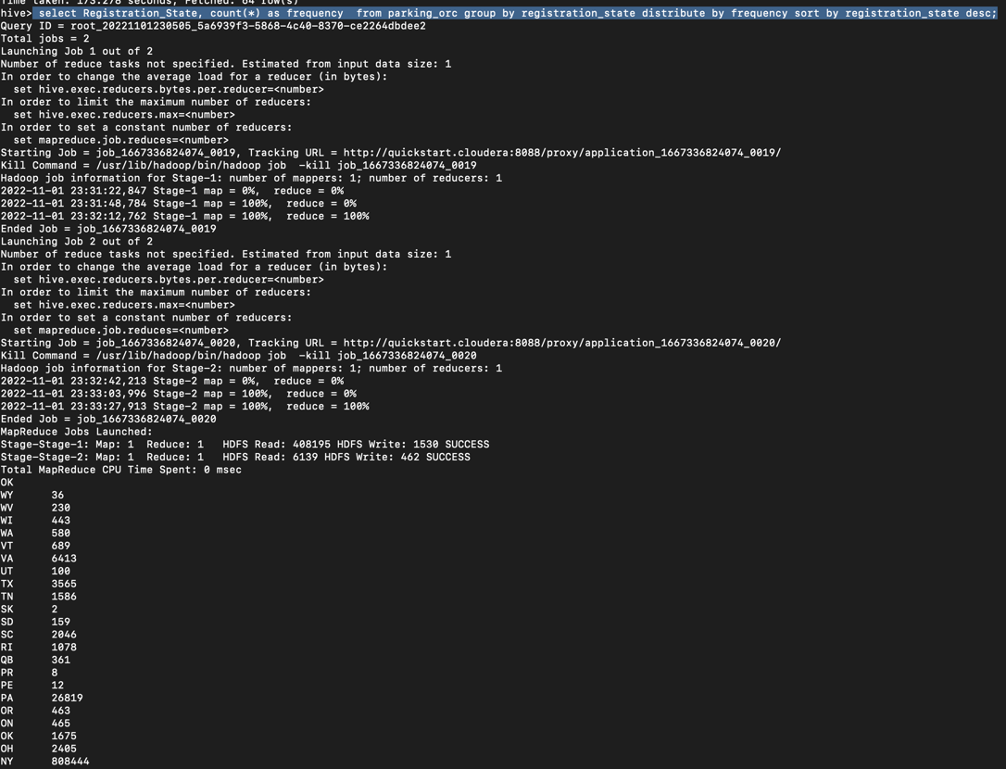

3.) Some parking tickets don’t have addresses on them, which is cause for concern. Find out how many such tickets there are(i.e. tickets where either "Street Code 1" or "Street Code 2" or "Street Code 3" is empty )

select Summons_Number from parking_orc where concat(street_code1,street_code2,street_code3) is null;

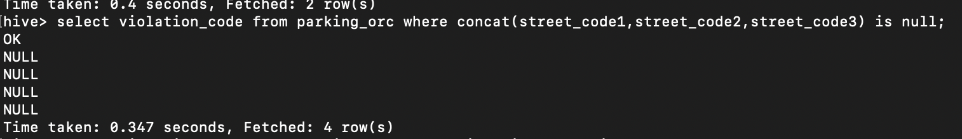

select count(Summons_Number) as number_of_tickets_with_no_address from parking_orc where street_code1 = 0 or street_code2 = 0 or street_code3 = 0;

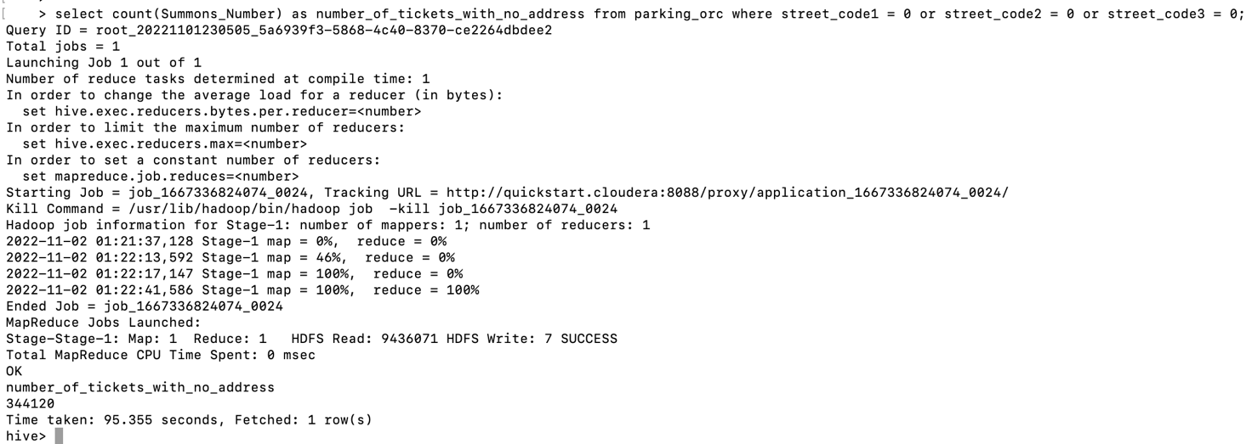

Part-II: Aggregation tasks

**1.How often does each violation code occur? (frequency of violation codes - find the top 5)**

#setting mode to strict

set hive.mapred.mode=strict;

Why strict mode ?

The reason is that in order to impose total order of all results, there has to be one reducer to sort the final output. If the number of rows in the output is too large, the single reducer could take a very long time to finish.

select count(violation_code) as frequency, violation_code from parking_orc group by violation_code order by frequency desc limit 5;

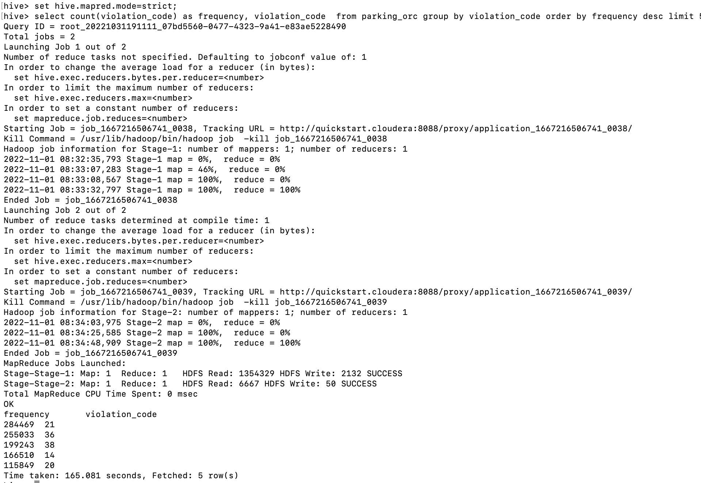

**2.) How often does each vehicle body type get a parking ticket? How about the vehicle make? (find the top 5 for both)**

set hive.mapred.mode=strict;

select count(violation_code) as frequency, vehicle_body_type from parking_orc group by vehicle_body_type order by frequency desc limit 5;

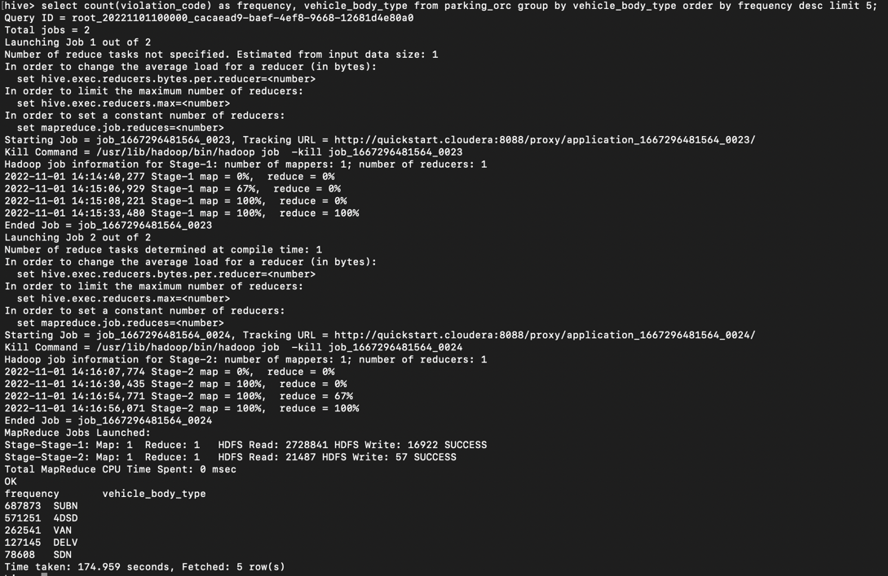

select vehicle_make , count(violation_code) as frequency from parking_orc group by vehicle_make order by frequency desc limit 5;

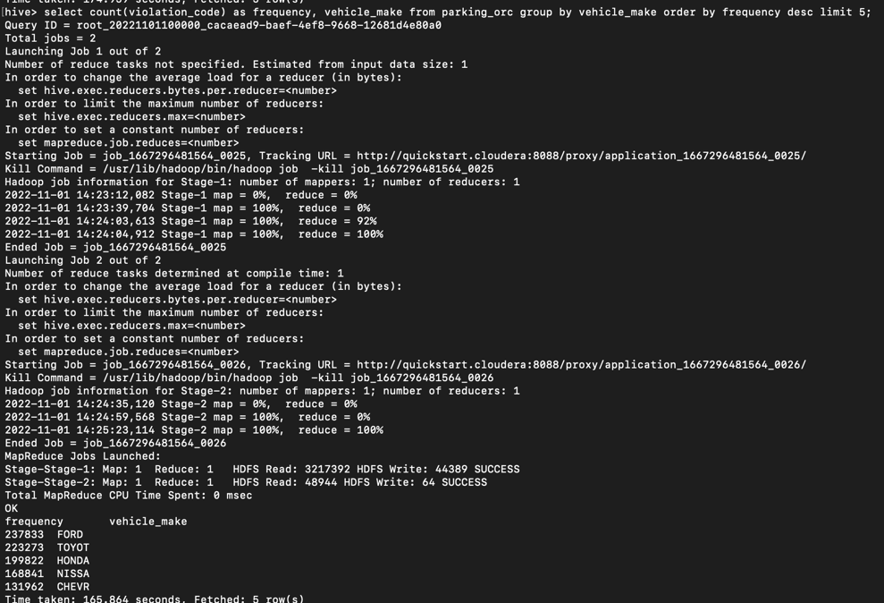

**3.) A precinct is a police station that has a certain zone of the city under its command. Find the (5 highest) frequencies of:**

**a.) Violating Precincts (this is the precinct of the zone where the violation occurred)**

set hive.mapred.mode=strict;

select violation_precinct, count(*) frequency from parking_orc group by violation_precinct order by frequency desc;

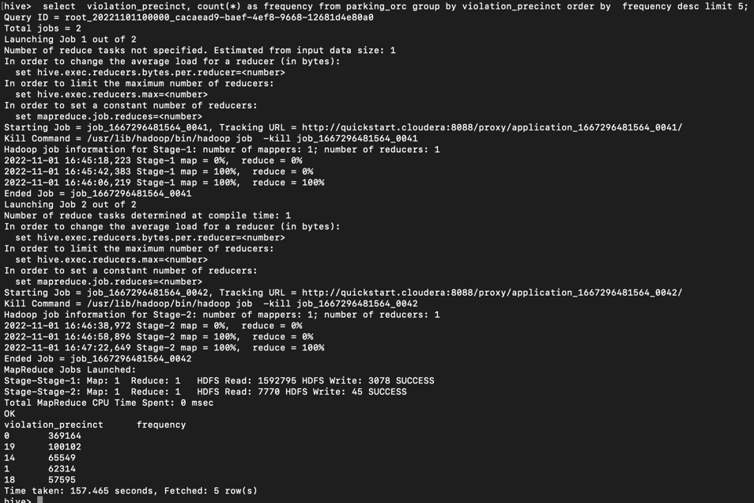

We believe that “violation_precinct=0” is something null/empty cell

**b.) Issuer Precincts (this is the precinct that issued the ticket)**

select issuer_precinct, count(*) as frequency from parking_orc group by issuer_precinct order by frequency desc limit 5;

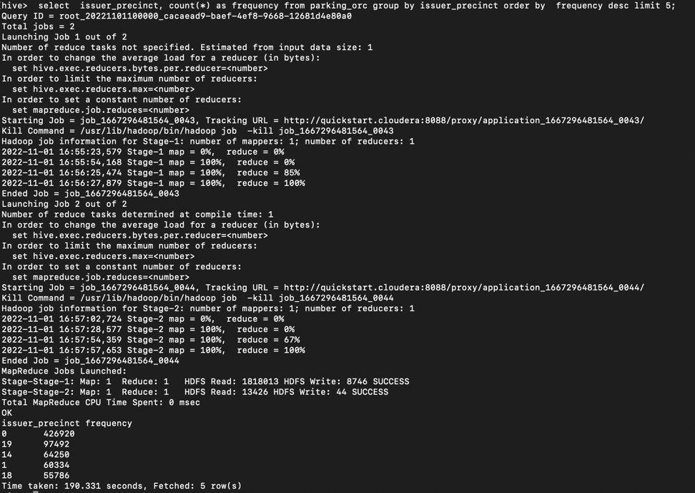

**4.) Find the violation code frequency across 3 precincts which have issued the most number of tickets - do these precinct zones have an exceptionally high frequency of certain violation codes?**

#from the above results we see that 19,14,1 are top most precinct zones

#create bucketing

create table issuer_precinct_bucket ( violation_code int , issuer_precinct int) clustered by (issuer_precinct) sorted by (issuer_precinct) into 3 buckets stored as ORC;

#insert data into bucketed table

insert overwrite table issuer_precinct_bucket select violation_code,issuer_precinct from parking_orc;

select violation_code ,count(violation_code)as violation_code_frequency, issuer_precinct from parking_orc where issuer_precinct in (19,14,1)

group by violation_code,issuer_precinct order by violation_code_frequency desc limit 5;

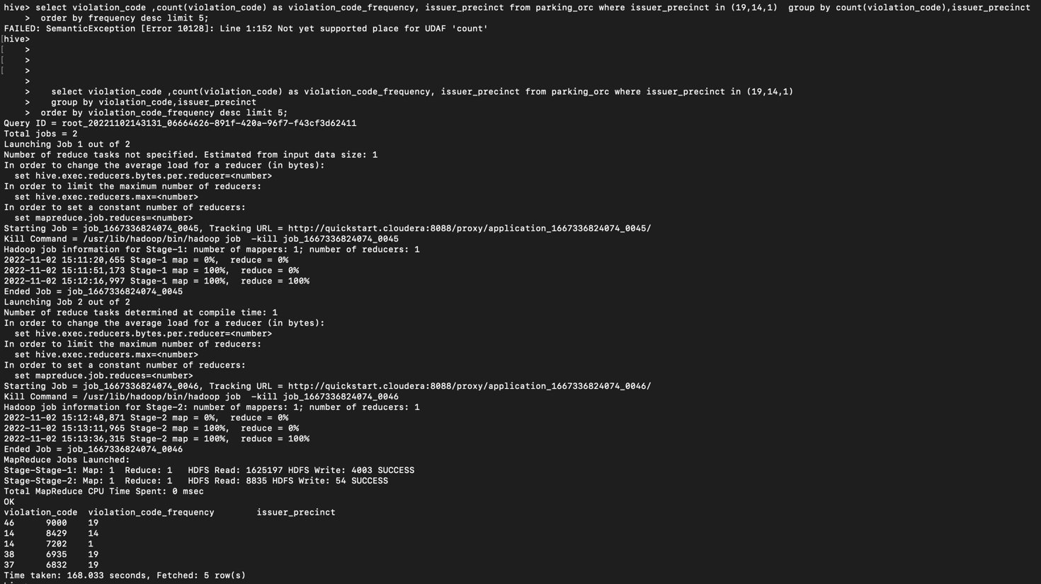

5.) Find out the properties of parking violations across different times of the day: The Violation

Time field is specified in a strange format. Find a way to make this into a time attribute that you can use to divide into groups.

**#createing table for time related data**

create table time_violations(summons_number string, violation_code int, violation_time string) stored as ORC;

**#inserting data with from parking_orc # time data is converted into 24 hours**

insert overwrite table time_violations select summons_number , violation_code, from_unixtime(unix_timestamp(regexp_replace(violation_time,'\P','\\PM'), 'hhmmaa'), 'HH:mm aa') from parking_orc where violation_time like '%P' ;

insert into table time_violations select summons_number , violation_code,from_unixtime(unix_timestamp(violation_time, 'hhmm'), 'HH:mm aa') from parking_orc where violation_time like '%A' ;

**6.) Divide 24 hours into 6 equal discrete bins of time. The intervals you choose are at your discretion. For each of these groups, find the 3 most commonly occurring violations**

**#dividing data in 6 bins #creating view and saving data in view**

Create view time_data as select violation_code, case

when substring(violation_time,1,2) in ('00','01','02','03') and upper(substring(violation_time,-2))=("AM") then 'bin_1'

when substring(violation_time,1,2) in ('04','05','06','07') and upper(substring(violation_time,-2))=("AM") then 'bin_2'

when substring(violation_time,1,2) in ('08','09','10','11') and upper(substring(violation_time,-2))=("AM") then 'bin_3'

when substring(violation_time,1,2) in ('12','13','14','15') and upper(substring(violation_time,-2))=("PM") then 'bin_4'

when substring(violation_time,1,2) in ('16','17','18','19') and upper(substring(violation_time,-2))=("PM") then 'bin_5'

when substring(violation_time,1,2) in ('20','21','22','23') and upper(substring(violation_time,-2))=("PM") then 'bin_6'

else null end as violation_bins

from time_violations where violation_time is not null or (substring(violation_time,1,2) in ('00','01','02','03', '04','05','06','07', '08','09','10','11', '12','13','14','15', '16','17','18','19', '20','21','22','23' ) and upper(substring(violation_time,-2)) in ('PM', 'AM'));

**#creating partitioned table**

create table time_partition (violation_code int) partitioned by (violation_bin string) stored as ORC;

**#loading data to partitioned table from view**

set hive.exec.dynamic.partition.mode=nonstrict;

insert overwrite table time_partition partition (violation_bin) select violation_code, violation_bins from time_data;

**# 3 most commonly occurring violations in each bin**

select violation_code, count(violation_code) as frequency from time_partition where violation_bin = 'bin_1' group by violation_code distribute by frequency sort by frequency desc limit 3;

select violation_code, count(violation_code) as frequency from time_partition where violation_bin = 'bin_2' group by violation_code distribute by frequency sort by frequency desc limit 3;

select violation_code, count(violation_code) as frequency from time_partition where violation_bin = 'bin_3' group by violation_code distribute by frequency sort by frequency desc limit 3;

select violation_code, count(violation_code) as frequency from time_partition where violation_bin = 'bin_4' group by violation_code distribute by frequency sort by frequency desc limit 3;

select violation_code, count(violation_code) as frequency from time_partition where violation_bin = 'bin_5' group by violation_code distribute by frequency sort by frequency desc limit 3;

select violation_code, count(violation_code) as frequency from time_partition where violation_bin = 'bin_6' group by violation_code distribute by frequency sort by frequency desc limit 3;

7.) Now, try another direction. For the 3 most commonly occurring violation codes, find the most common times of day (in terms of the bins from the previous part)

select violation_code, count(violation_code) as a from time_date group by violation_code distribute by a sort by a desc limit 5;

select violation_bins, count(violation_bins) from time_data where violation_code in ('21','36','38') group by violation_bins ;

**8.) Let’s try and find some seasonality in this data**

**a.) First, divide the year into some number of seasons, and find frequencies of tickets for each season. (Hint: A quick Google search reveals the following seasons in NYC: Spring(March, April, March); Summer(June, July, August); Fall(September, October, November); Winter(December, January, February))**

**#creating view and saving data in view**

create view seasons_view as Select violation_code, issue_date, case

when substring(issue_Date,1,2) in ('12','01','02') then 'winter'

when substring(issue_Date,1,2) in ('03','04','05') then 'spring'

when substring(issue_Date,1,2) in ('06','07','08') then 'summer'

when substring(issue_Date,1,2) in ('09','10','11') then 'fall'

else 'not_defined' end as seasons

from parking_orc where issue_date is not null or ((length(issue_date)=10 and substring(issue_date,1,2) in ('12','01','02','03','04','05','06','07','08','09','10','11'))) ;

#**finding the frequencies of tickets for each season**

select count(violation_code) as ticket_count, seasons

from seasons_view

group by seasons order by ticket_count desc

**#creating partition table**

create table season_partition(violation_code int, issue_date string) partitioned by (seasons string) stored as ORC;

**#inserting data from view to partitioned table**

insert overwrite table season_partition partition (seasons) select * from seasons_view;

**b.)Then, find the 3 most common violations for each of these seasons.**

select violation_code, count(violation_code) as frequency from season_partition where seasons = 'winter' group by violation_code distribute by frequency sort by frequency limit 3;

select violation_code, count(violation_code) as frequency from season_partition where seasons = 'fall'group by violation_code distribute by frequency sort by frequency limit 3;

select violation_code, count(violation_code) as frequency from season_partition where seasons = 'summer' group by violation_code distribute by frequency sort by frequency limit 3;

select violation_code, count(violation_code) as frequency from season_partition where seasons = 'spring' group by violation_code distribute by frequency sort by frequency limit 3;

Note: Please ensure you make necessary optimizations to your queries like selecting the appropriate table format, using partitioned/bucketed tables. Marks will be awarded for keeping the performance also in mind.